# **12 Advantages Of Digital Marketing Over Traditional Marketing**

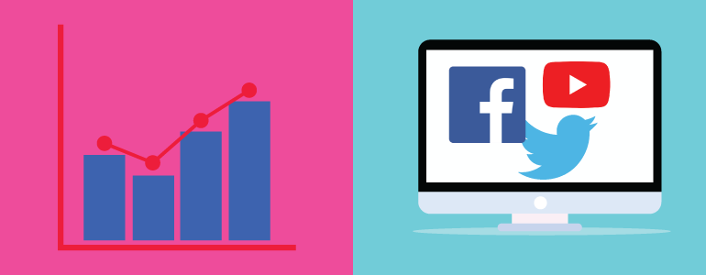

## **Traditional marketing:**

The action of selling and promoting products via advertising has been the revolution in business. This is what we refer to as marketing. So, marketing all begins with traditional ways. It has many facets. It includes printing ads in magazines and newspapers, selling out the brochures and pamphlets for free and printing business cards. It also includes the commercialization on radio, tv, posters and billboards. So, predominantly there are many ways by which you can advertise your product. And they are good in their own aspect.

Traditional marketing is very profit oriented and aims on production only. Most common strategy businessmen use is business cards. Companies that use traditional marketing are “Pakka Indian” Marketing Campaign by McDonald's, Magazines for Women, Business Magazines. Entrepreneurs are quite friendly with traditional marketing. They are familiar with long and stories text which is suitable to consumers also. Traditional marketing is basically explicit as to how far you would like to go in history.

## **Digital marketing:**

Digital marketing is based on sought after technology. It is a component of marketing that utilizes internet and online based work. It uses many technologies like laptops, mobile phones and many digital platforms. It helps companies to drive sales and get more organic traffic and provides a method by which companies endorse goods, services and brands. SEO companies provide lots of opportunity to promote your brand by providing manySEO marketing services that have been a boon in driving sales. Email marketing, pay-per-click advertising, social media marketing, blogging and digital sponsorship all are great examples of digital marketing. They drive a lot of organic traffic by introducing your company to the audience and this enhances your sale.

There are three types of digital marketing: earned media, owned media and paid media. Earned media- 1. customer reviews and testimonial

2. Mentions on any social media platform

3. Magazines and newspaper articles

Owned media- 1. Email marketing campaigns such as company newsletters.

2. Blogs and other owned content.

Paid media- 1. sponsorships

2. paid search results and paid advertisements

## **Advantages of digital marketing over traditional marketing:**

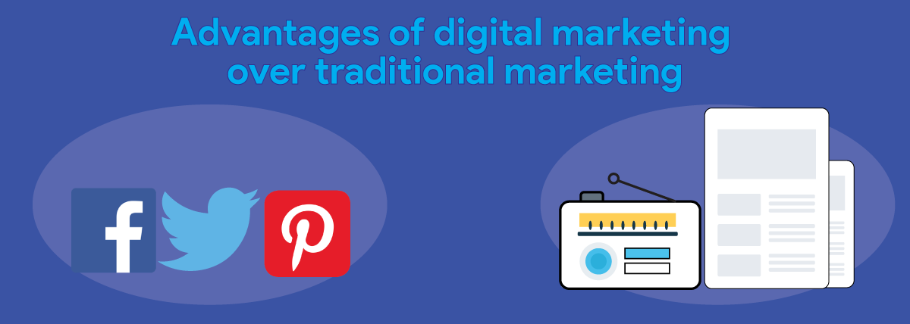

### **Low cost-**

for marketing and advertising your product, you ought to exorbitant your money. and for startups or small businesses it is not possible to invest so much money in traditional marketing. Digital marketing relieves you from the financial burden businesses have to face. For big businesses it is possible to dol out money but for deserving startups it is like a bad nightmare and this closes the opportunity of advancing for them. Marketing on digital platforms is quite affordable as compared to the traditional marketing.

### **Huge return on investment-**

People these days are more active online than offline and this helps to increase your return of interest. The money which you will spend on marketing would be less as compared to the profit you will earn and the chances of this is more in digital marketing. Return of interest matters a lot for any business.

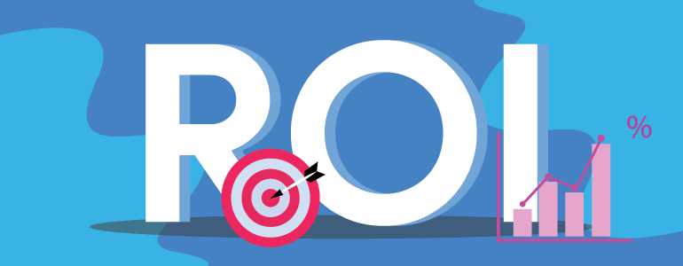

Email marketing campaigns and advertising campaigns are inexpensive compared to traditional marketing techniques.

### **Easy to measure-**

the success rate in digital marketing is ascertained and you do not have to wait for a longer time to see the result. In traditional marketing you have to wait for weeks to see the veracity of a campaign but not in digital marketing. You would easily observe the performance of the ad in less time. Email marketing companies help the business to track the records by observing how many are delivered, how many are read and how many conversions you got by this.

### **Easy to adjust-**

In digital marketing, it is quite easy to observe the performance of an ad and then you can instruct the business accordingly on how they have to modify their sales. It is very easy to adjust in digital marketing because for new modifications you just have to click. But in traditional marketing, so much paperwork is involved and it becomes rigid to make modifications and the results are also shown late.

### **Brand’s development-**

digital platforms and Search engines are very responsible for the development of the brand and spread awareness about the company. There are many digital ways by which you can promote your brand like making websites, articles, blogs and many social media platforms that help you to increase your brand.

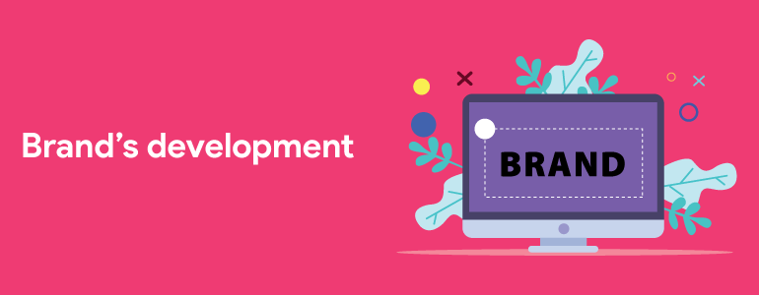

### **Easy to share-**

Digital platforms offer you to share your campaigns and advertisements to millions of followers which is quite impossible in traditional campaigns. In digital marketing one follower can send the profile of your company on social media to many of his friends and family which drives many followers. This tremendously improves the sales result and creates a multiplier effect.

### **Precise targeting-**

the traditional approach of marketing is that they use spray and pray method where they put offline campaigns to many places and spend a lot of amount of money in a hope that it might get them some audience but this decreases the return of interest and it takes a lot of time to get high return of interest. But in digital marketing they follow a targeting approach where they target a bulk of the audience and with the goal to turn them into conversions. And most importantly you get a high return of interest. You don't need to bother customers again and again to buy your product. They will get what they want. Emails are sent only to those customers who show interest in your product. Marketing through social media is a very smart approach. It studies the algorithm properly and collates user preference by showing your ad campaigns to only specific users.

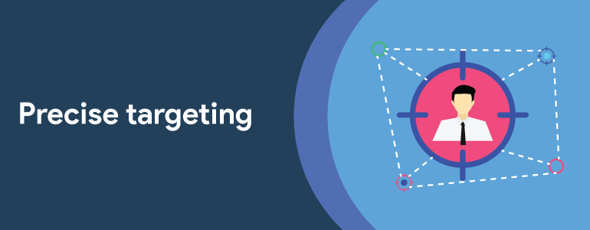

### **Global:**

Digitalization has opened many doors. Not only that it has turned the world into a global village. Ad campaigns are now visible in any part of the world with the help of digital marketing. It provides the immense exposure that gives the small start ups the rare opportunity to go global. There are a lot of stories on the internet of startups that became hugely successful over a small period of time thanks to the opportunities provided by the global nature of marketing via digital platforms.

### **Segmentation:**

Marketing over digital platforms not only allows campaigns to be targeted at specific customers but also allows for customer segmentation. The process in which large customer groups are broken down into smaller groups of customers according to a particular classification is known as segmentation. Chances of sales are increased and cost is cut down through segmentation

### **10. Greater Engagement:**

The cyber world is getting crowded and nosier day by day, and anything that your business provides or offers in the present or future is most likely also being offered by thousands of other businesses. As a result the average bounce rate on the websites is increasing and the attention span of visitors is dropping. It is like whenever the visitors find a website for the thing they were looking for, they do not find any alternative or think of a better option. And if they don’t only then they go for an alternative.

### **11. Strategize with the valuable data and analytics:**

search engines provide you the information about the number of people visiting your website and help you to analyse and track stats. It also tells you the geographic location and the source of traffic from various gadgets.

### **12. Content performance and lead generation-:**

digital platforms provide you the information about the product and services through influencers. Google consider your content worthy if you get more conversions.

## **Conclusion:**

Well, successful businessmen use both the approaches and that is why they are so progressive. You just have to figure out which to use where. Both types of marketing, therefore digital and traditional are good in their own aspect. Just use them wisely and precisely.